**Assignment-UI/UX**

**Dream Catcher App**

**Aim:**

Create an app for **tracking and interpreting dreams**.

**Procedure:**

1. **Collect Information**: Gather details on dream symbolism, psychological insights, and sleep patterns.
2. **Create Canvas**: Design the app layout with sections for **dream journal**, **mood tracker**, and **interpretation insights**.
3. **Add Elements**: Use soothing images, calming colors, and intuitive icons (e.g., moon, stars).
4. **Build Donation Platform**: Allow users to log dreams, track mood, and receive AI-powered dream interpretations.
5. **Prototyping**: Create an interactive prototype using **Figma** to test navigation and user flow.

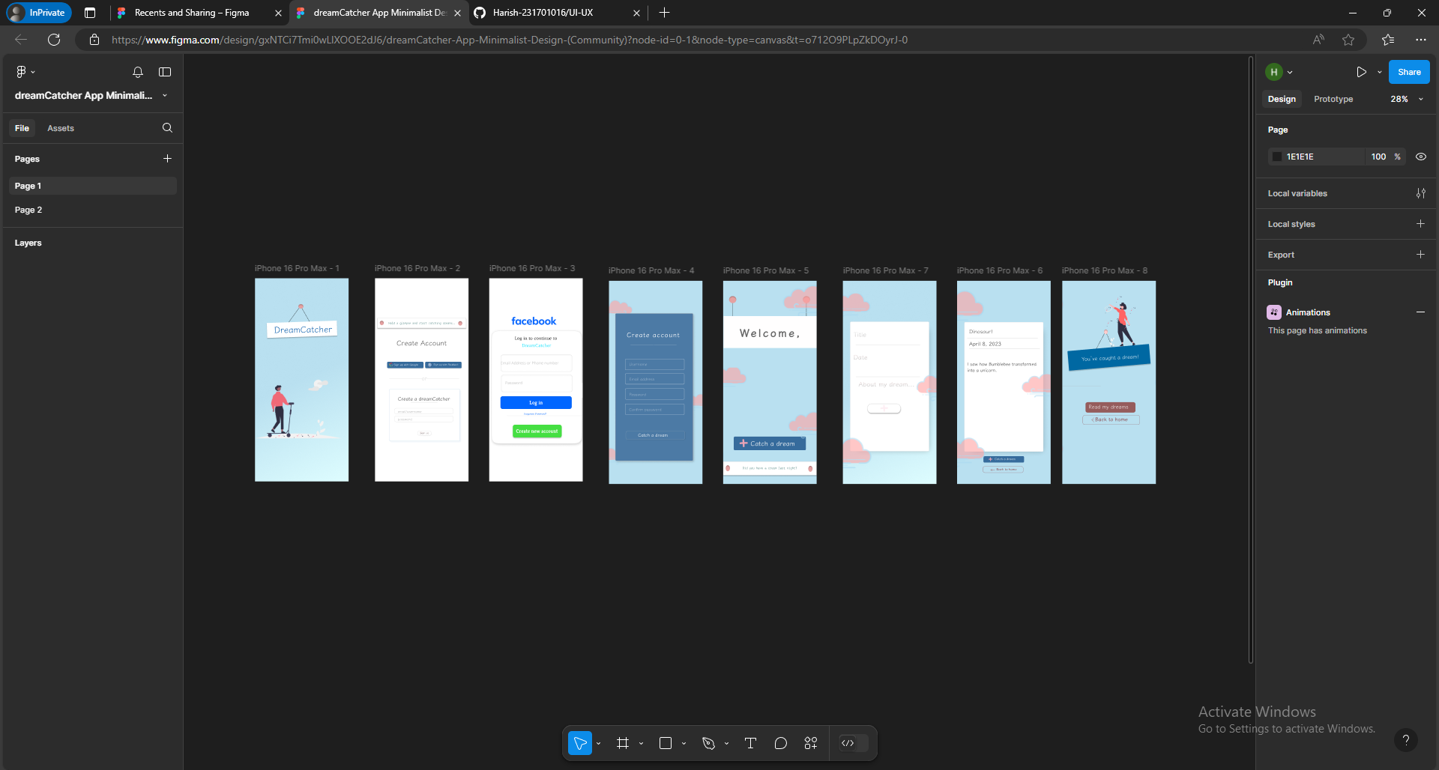

**Result:**

**Dream Catcher App design** is **complete** and **verified**.